Contestant Number: ____________________
Time: ___________________
Rank: _______________



PERSONAL FINANCIAL MANAGEMENT
(165)

NATIONAL 2021

Multiple Choice:
30 @ 2 points each (60 points)
Short Answer Problems:
23 @ 3 points each (69 points)

TOTAL POINTS (129 points)

Test Time: 60 minutes

General Instructions
The number of decimal places used in calculations and in the reporting of your answers is very important. Below are guidelines to use as you take this test. If a problem varies from these guidelines, it will be noted in the problem.
PERCENTAGE PROBLEMS
- Round to the nearest tenth when working with percentages.

Example: Use 2.3% NOT 2%
Example: An answer of .9638 should be written as 96.4%
INTEREST
- All interest rates are stated in one-year simple interest, unless otherwise noted.
- Interest is to be calculated on 360 days.

DOLLAR AMOUNTS
- All dollar amounts must be rounded to the second place (nearest cent).

Example: $35.9765 to $35.98

- Which of the following most accurately describes the nature of a debt securities?
  - The investor buys ownership into mortgage-backed securities.
  - It is a term used to categorize investments into organizations such as payday lending institutions.
  - It is a term used when a borrower uses security investments as collateral for new debt.
  - The investor does not buy ownership in an organization but lends it money instead.

- Spencer has a health insurance policy that costs him $200 a month, has a $2,500 deductible, and an 80/20 coinsurance split. His first medical bill of the year was for $875. How much of that will his insurance pay?
  - None
  - $175
  - $700
  - $875

- Samantha always buy clothes from whichever store is offering the biggest percentage discount sale. Knowing that, which of the following would she most likely buy from based on the percentage discount offered?
  - $85.00 on sale for $68.00
  - $60.00 on sale for $51.00
  - $25.00 on sale for $18.75
  - $55.00 on sale for $38.50

- Rebecca works hard to build and maintain good credit. Which of the following practices is most likely having the greatest impact on her credit score?
  - Keeping a good credit mix by having a credit card, car loan, and two student loans.
  - Never missing a payment or being late with payments.
  - Spreading out her applications to never apply for more than one loan every six months.
  - Paying off credit card balances at the end of every month and never carrying over balances.

- Francisco is getting a new apartment and just sat down to review the move-in financial costs. Rent is $1,200 a month. When he signs the lease, he must deposit first and last month’s rent, a $250 security deposit, and a $300 pet deposit. How much will he need to provide in total?
  - $2,950
  - $1,200
  - $1,750
  - $2,400

- Amari and Izem are roommates and split the rent equally between them. Which of the following best describes what will happen if Izem cannot pay his half of the rent?
  - Amari is not required to pay any rent if Izem does not pay his share.
  - If Amari does not pay the entire rent, both of their credit scores could be damaged.
  - Amari’s credit will be safe as long as he pays his half of the rent.
  - Amari will have to pay the entire rent, but Izem’s credit will still be damaged.

- Which bond rating indicates an investment grade rated bond?
  - BBB
  - BCC
  - CCC
  - CDD

- Which of the following best describes how banks calculate the interest charged for credit card usage?
  - Interest is calculated annually based on the total money spent throughout the year.
  - Interest is calculated monthly on balances carried over from the previous month.
  - Interest is calculated weekly on the total amount that was spent that week.
  - Interest is calculated using the average daily balance over the course of the month.

- If I invest $5,000 at 9% simple interest for 3 years, what is the maturity value?
  - $2,150
  - $7,150
  - $6,350
  - $1,350

- If a person gets prequalified by a lender, that means they are guaranteed to get a mortgage loan.
  - True
  - False

- Which of the following is most likely not a factor that insurers consider when determining the premium they will charge a population for a health insurance policy?
  - Occupation
  - Geography
  - Type of car owned
  - Smoking habits

- Identify the word or phrase from the following options that best completes the sentence:
“As a preferred stockholder, Esmeralda has a greater right to claim assets in the case of company solvency than _____.”
  - anyone else
  - common stockholders
  - the IRS
  - the board of directors

- Bailey works at a sandwich shop and gets paid $9.00 per hour. One week she clocked in 48 hours. Taking into consideration a typical overtime pay scale, how much will Bailey earn for that week?
  - $468
  - $451
  - $475
  - $432
The graphs below show the stock performance for Company XYZ over a two-year period. The first chart shows performance values for the 12 months during 2018. The second includes the 24 months of both 2018 and 2019. Shares opened at $16.15 in January 2018 and closed the year at $17.78. It closed 2019 at $21.21 per share.
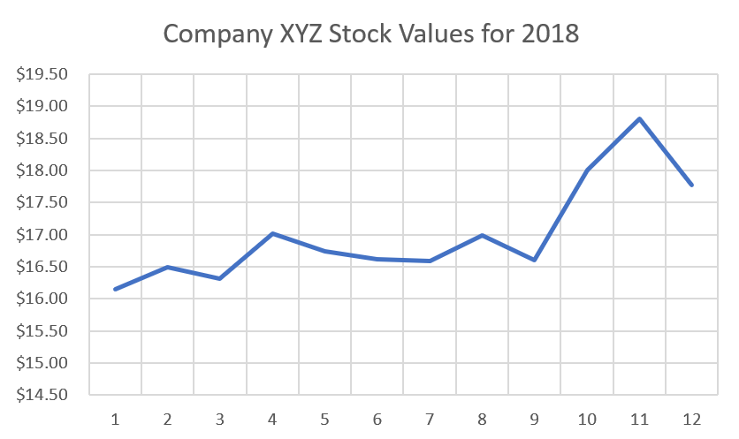 | 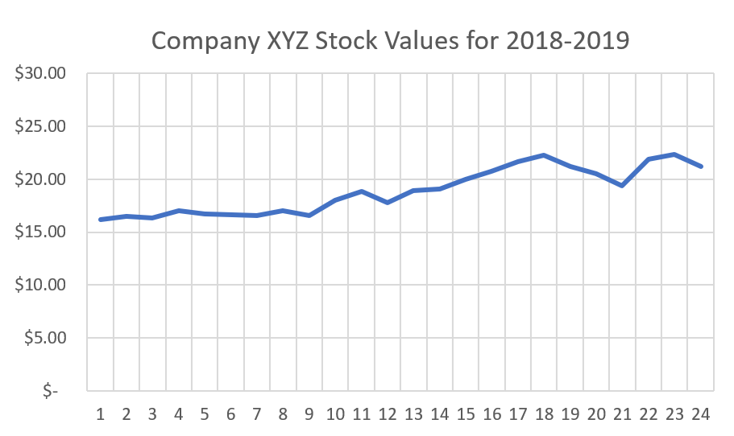

- Which of the following would not be considered true about the company’s two-year performance?
  - Investors that panicked at the end of 2018 may have sold their shares prematurely.
  - The company should be considered a volatile long-term investment.
  - Overall, the stock has maintained consistent growth over the course of two years.
  - The value of the stock increased more in 2019 than in 2018.

- Malik and Samir both bought 200 shares of Company XYZ in January of 2018. Malik sold his shares in December of the same year. Samir did not sell his until December of 2019. How much more money did Samir make than Malik?
  - $465.69
  - $325.15
  - $140.54
  - $686.00

- If I have $164,350 earning 13% interest, about how long can I estimate it will take to double my money?
  - A little over twelve years
  - There is not enough information provided to calculate an estimate.
  - About three years
  - About five and a half years

- Cecilia has had her car for a few years after buying it new. The car is a popular sedan with cherry-red paint, but it isn’t a sport model. Although it has excellent safety features, her insurance is rather pricey. Which of the following most likely explains why her insurance is so expensive?
  - Cecilia has only taken one driver’s safety course.
  - Cecilia is married and has three children.
  - Cecilia drives about 700 miles a month.
  - Cecilia lives in downtown Chicago.

- Jasmine is considering a career as a public relations specialist and anticipates a starting salary of about $45,000. Considering it will cost about $34,000 to get the degree from her preferred school, what will the ROI be after the first year in her career?
  - 17%
  - -27%
  - 32%
  - 126%

- Janica graduated from college about 10 years ago and has never missed a payment on her student loans. It has been easy because her payments started out really small and have gotten a little bigger each year as she has progressed through her career. What kind of repayment plan is she most likely on for her student loans?
  - Federal Subsidized Plan
  - Graduated Repayment Plan
  - Standard Plan
  - Fixed Payment Plan

- Preferred stock shares have greater voting rights to common stock shares.
  - True
  - False

- Which of the following best describes a major problem with typical savings accounts?
  - They are not as secure of an option for your money as they used to be.
  - There are penalties and limitations associated with money withdrawals.
  - The interest rates are often lower than inflation rates.
  - Their interest rates often fluctuate with the stock market performance.

- If Tau pays $80 toward his credit card debt this month in addition to his minimum payment of $142, assuming 30% of his regular payment goes to interest, about how much will his credit card debt reduce by this month?
  - $130
  - $100
  - $180
  - $120

- Bond prices have an inverse relationship to interest rates.
  - True
  - False

- How much interest would be earned if $6,000 were invested for 20 years, at an interest rate of 11% compounded annually?
  - $52,610.87
  - $13,200.00
  - $48,373.87
  - $53,610.09

- Anthony backed his car into a fence and caused some pretty bad damage to his bumper. This will be the fourth time he has filed a claim with his car insurance. Which of the following best describes why his insurance rates may increase as a result?
  - By repeatedly filing claims, Anthony is showing that he is a financial liability.
  - Most insurance companies have a three-strikes policy before they raise premiums.
  - Insurance companies only raise rates if accidents involve other drivers.
  - Every time a claim is filed it results in insurance premiums increasing regardless of the circumstances.

- Eric owns preferred stock in Company ABC which has recently fallen on hard times and not been able to make its regularly scheduled dividend payments. As a result, which of the following statements is most likely true?
  - Eric is eligible to convert his unpaid dividends into additional equity.
  - Eric will claim his lost earnings as a tax deduction.
  - Once the company is able to start paying dividends again, Eric will be among the first to get paid.
  - The company will eventually have to pay Eric his dividends with interest.

- Due to their nature of providing steady dividends and stable trading prices, preferred stocks are often compared to, and even rated similarly to, which other kind of investment?
  - Real estate
  - Foreign currency exchange
  - Certificates of deposit
  - Bonds

- What does the term “claim” mean with respect to auto insurance?
  - It is used to describe when a policy holder requests the insurance company to pay for an event that is covered by the insurance policy.
  - It describes the maximum amount of money an insurance company will pay out over the course of one year for various events covered by a policy.
  - It refers to who is claiming responsibility to an accident.
  - It refers to the official report describing the police assessment of the accident.

- Identification factors appear on your credit report that do not impact your credit score but can impact whether or not you get approved for a loan.
  - True
  - False

- Which of the following best describes the difference between investing in bonds and investing in traditional stocks?
  - Bonds are a risk-free investment whereas the stock market is volatile by nature.
  - Profits from bonds come from interest paid by the organization instead of dividends paid out as a result of excess revenue.
  - Investing in stocks always produces higher long-term returns than bonds.
  - Traditional stock investments are part of diverse portfolios far more often than bonds.

Short Answer Problems – 3 points each

- Emma has health insurance coverage through her company. She pays a premium of $60 each biweekly pay period that is deducted from her paycheck. The policy includes a $500 deductible, a 75/25 coinsurance after the deductible, and an out-of-pocket maximum of $5,000 annually. She incurs the following medical services for 2020:
    - Doctor visit in March, cost of $200
    - Emergency room visit in April with an x-ray, cost of $1,500
    - Doctor visit in August, cost of $400
    - Outpatient surgery in November, cost of $4,500

  - How much did Emma pay for her 1st doctor visit?

  - How much did Emma pay for her emergency room visit in April?

  - How much did the insurance company pay for her surgery in November?

  - Did Emma reach her out-of-pocket maximum during 2020?

  - How much in total did Emma pay for her 2020 medical insurance and services?

- On May 1, 2019, Charlie buys a 6%, $5,000 bond, paying $4,200. The bond pays interest semi-anually. The market price on May 1, 2021 for that same bond has risen to $4,400.

  - How much did Charlie receive on the 1st interest payment, November 1, 2019?

  - Is this an example of a premium or a discount bond?

  - On May 1, 2021, what is the current yield of the bond?

  - How much will the interest payment be on November 1, 2021?

- Kristy works as a software developer, a job that paid her a salary of $78,500 in 2020. Her company rewarded her performance with a 5% raise for 2021. Kristy is paid biweekly. She has 20% of her salary withheld for income tax, 6.2% for Social Security tax, and 1.45% for Medicare tax. She elects to deduct 4% of her salary as a contribution to her 401(k) plan. The company matches her contribution at 50%. Kristy also elects to deduct 2% of her salary into a company stock purchase program.

  - What is Kristy’s 2021 annual salary?

  - What is Ashley’s biweekly 2021 contribution into her 401(k)?

  - How much does Kristy’s company contribute toward her 401(k) each pay period in 2021?

  - Assuming her company’s current stock price is $20.45 per share, how many shares of stock could Kristy buy in one pay period?

  - How much in taxes are withheld each pay period in 2021?

  - What will Kristy’s net pay be each 2021 pay period?

- Cameron owns a landscaping company. Because of the upcoming slow winter season for his business, he needs to take out a personal loan on November 21st, 2020 in the amount of $4,280. The interest rate for the loan is 4.15%, and the term of the loan is 180 days.

  - How much in interest will Cameron have to pay upon maturity?

  - What is the maturity date?

  - Cameron cannot pay back his loan at the maturity date, so the bank charges him a 5% fee on the maturity value, and allows him to take out a 2nd loan on this new amount, the maturity value plus the fee. The new loan has terms of 60 days and 3.75% interest. What will be the maturity value on the new loan?

- Laticia had never owned any stock, but decided to this past year. During 2020, she made the following stock transactions through an online investment account:
Jan 3rd, Bought 40 shares of Tipton Industries @ $30.50
Jan 24th, Bought 25 shares of Readimed Corp @ $62.15
July 18th, Sold 20 shares of Tipton Industries @ $34.68
Aug 8th, Bought 10 shares of Wolf Inc @ $132.20
Oct 20th, Sold 25 shares of Readimed Corp @ $70.10

Stock values as of December 31st, 2020 were:
Readimed Corp - $73.24
Tipton Industries - $41.38
Wolf Inc. - $127.75

- How much money in total did Laticia invest during 2020?

- What amount of dollar gain did Laticia realize on her July sale of Tipton Industries stock?

- What was the ROI on her October sale of Readimed Corp stock?

- How much more money would Laticia have made if she sold her Readimed stock on December 31st rather than on October 20th?

- At the end of 2020, what was the value of Laticia’s stock portfolio?

